Sri Lanka Institute of Information Technology



**Assignment 1**

**MLB_PG_02_02_02**

**Life Insurance Management System**

**Information Systems and Data Modelling (ISDM) - IT1060** B.Sc. (Hons) in Information Technology

**IT1060– Information Systems and Data Modelling 2021 February - June**

## Assignment Cover Sheet

|  |  |
| --- | --- |
| **PROJECT ID** | MLB_PG_02_02_02 |
| **CASE STUDY NAME** | Life Insurance Management System |
| **CAMPUS/CENTER** | Malabe campus |

**Group Details:**

|  |  |  |
| --- | --- | --- |
|  | **Student Registration Number** | **Student Name** |
| **1** | IT20636456 | B..G.T.D.Kaushani. |
| **2** | IT20166342 | Hettiarachchi.H.A.G.D. |
| **3** | IT20643768 | Jayakody.J.A.R.R. |
| **4** | IT20641856 | S.D.Ranaweera. |
| **5** | IT20166274 | Abeyrathna.H.K.H |

1

**IT1090– Information Systems and Data Modelling 2020 February - June**

## Assignment Certify Sheet

## 

We hereby certify,

* The attached is our own work and no further changes will be made.

* We have contributed in this assignment to the best of our ability.

**Group Details:**

|  |  |  |  |  |
| --- | --- | --- | --- | --- |
|  | **Student Name** | **Student**  **Registration Number** | **Date** | **Signature** |
| **1** | B..G.T.D.Kaushani. | IT20636456 | 13 /05/2021 |  |
| **2** | Hettiarachchi.H.A.G.D. | IT20166342 | 13/05/2020 |  |
| **3** | Jayakody.J.A.R.R. | IT20643768 | 13/05/2020 |  |
| **4** | S.D.Ranaweera. | IT20641856 | 13 /05/2020 |  |
| **5** | Abeyrathna.H.K.H | IT20166274 | 13 /05/2020 |  |

2

**HYPOTHETICAL SCENARIO**

In a life insurance management system (LIMS) have two types of users are there who can access the system. They are guest (user) and the customer (register user). The system allows the guests to view the website and the customer can view the system and use the website after registering to the system.

Customer in the LIMS can ask for insurance and view the user details. Another facility is customers can update their profiles. If they already have insurance with LIMS, we will pay their hospital bills in the event of an accident. If customer want to start a new insurance first they have to select suitable insurance plan and then they have to fill insurance form.

Employees are the other major actors in our LIMS. We have so many employees like manager, accountants, insurance underwriter, claim clerk, sales agent etc. If customer want to know more details about insurance, they can get direct conversation with sales agent. Accountant is another special actor in LIMS. Because he can analyze all the financial reports and view profit in system. If customers want to get their claim, they must contact claims clerk. Because only claims clerk can accept or refuse compensation and determine the amount of compensation.

Admin is owned by staff and admin also manage the staff and the customers in website. Furthermore admin can update or remove existing insurance plans and add new insurance plans.

**2.0 Requirements Analysis.**

**2.1 Main Requirements of The System.**

The life insurance management system can be easy to customer for view insurance type, insurance details and also, he/she can pay for the insurance using life care insurance website. Life insurance management system has requirements and system developed depended on the requirements. Requirement is a description of services which system will provide to the user. The requirements divide in two parts such as functional requirements and nonfunctional requirements.

**Functional Requirements**

Functional requirements are those which are related to the technically functionality to the system. Functional requirements define how the users interact to the system. There are many main functional requirements. The following are some of them. Unregister user, register user (customer), Administrator and all users can access to the website. But accessible area different from others.

**Guest/User**

**User requirements :**

* The system prevents users can access only home page, about us, contact us page due to registration. They won’t be able to browse other pages until they register to the system.
* User should enter the correct details to login to the system. If the user forgot password, user should enter the valid email and phone number then user can reset the password.
* User can contact social media and contact number.
* Create an account for Guest (unregister user).
* User can browse website and review relevant information such as company profile , available insurance type and details of those.
* Users can make payments for the insurance cover.
* User can open a new insurance cover and get details report of current insurance cover.
* Guest and users must access to the front end.

**System requirements :**

* System should store all the details of users.
* System allows for the new registration.
* System should store the payment details of the user and check validation of the payment details.
* Check the validation of the login details.
* Display the contact details to the user and guest.

**Administrator (developer)**

**User requirements :**

* Administrator can update the details and manage the staff.
* Administrators view all user accounts and manage all insurance plans.
* Admin can edit the database.
* Admin must access to the front end and back end to the system.

**System requirements :**

* System store customer details.
* System allows for new updates.
* Check the validation of added details and add insurance.

**Non-Functional Requirements**

Nonfunctional requirements mean implicit assumptions in the system. The operating characteristics of the system are defined by nonfunctional requirements.

**Availability**

* The system open 24 hours for the users. They can access any time and use the services.

**Reliability**

* If a user enters invalid information to registration form the system should identify the invalid user credentials.
* System should be correctly validation of the user’s insurance payment and their payment methods.

**Usability**

* The user has to understand the insurance system once and for all.

**Security**

* The system would have password protected access to web pages that only administrator will be able to see.
* Payment information must be sent in an encrypted format.

**2.2 Data requirements of the system**.

**Customer (User):**

* User first name (F_name)
* User last name(L_name)
* CID
* Age
* NIC
* Address
* Email
* Gender
* contact_no

**Sales Agent :**

* Sales agent first name (F_name)
* Sales agent last name(L_name)
* SID
* NIC
* Email
* Address
* Salary
* contact_no

**Branch :**

* Name
* BID
* Email
* Address (city, street)

**Manager :**

* Manager first name (F_name)
* Manager last name(L_name)
* NIC
* MID
* contact_no
* Address
* Email
* Salary

**Insurance Underwriter :**

* Insurance underwriter first name (F_name)
* Insurance underwriter last name(L_name)
* NIC
* UID
* Email
* Address
* contact_no
* salary

**Claim Clerk :**

* Claim clerk first name (F_name)
* Claim clerk Last name (L_name)
* NIC
* Address
* CLID
* Email
* Salary
* Contact_no

**Accident :**

* Report_no
* Details

**Insurance policy :**

* Policy_ID
* coverage

**Payment :**

* PID
* Payment_type
* Amount

**Insurance :**

* INO
* Insurance_type
* Monthly installement

## Entity Relationship (ER) Model

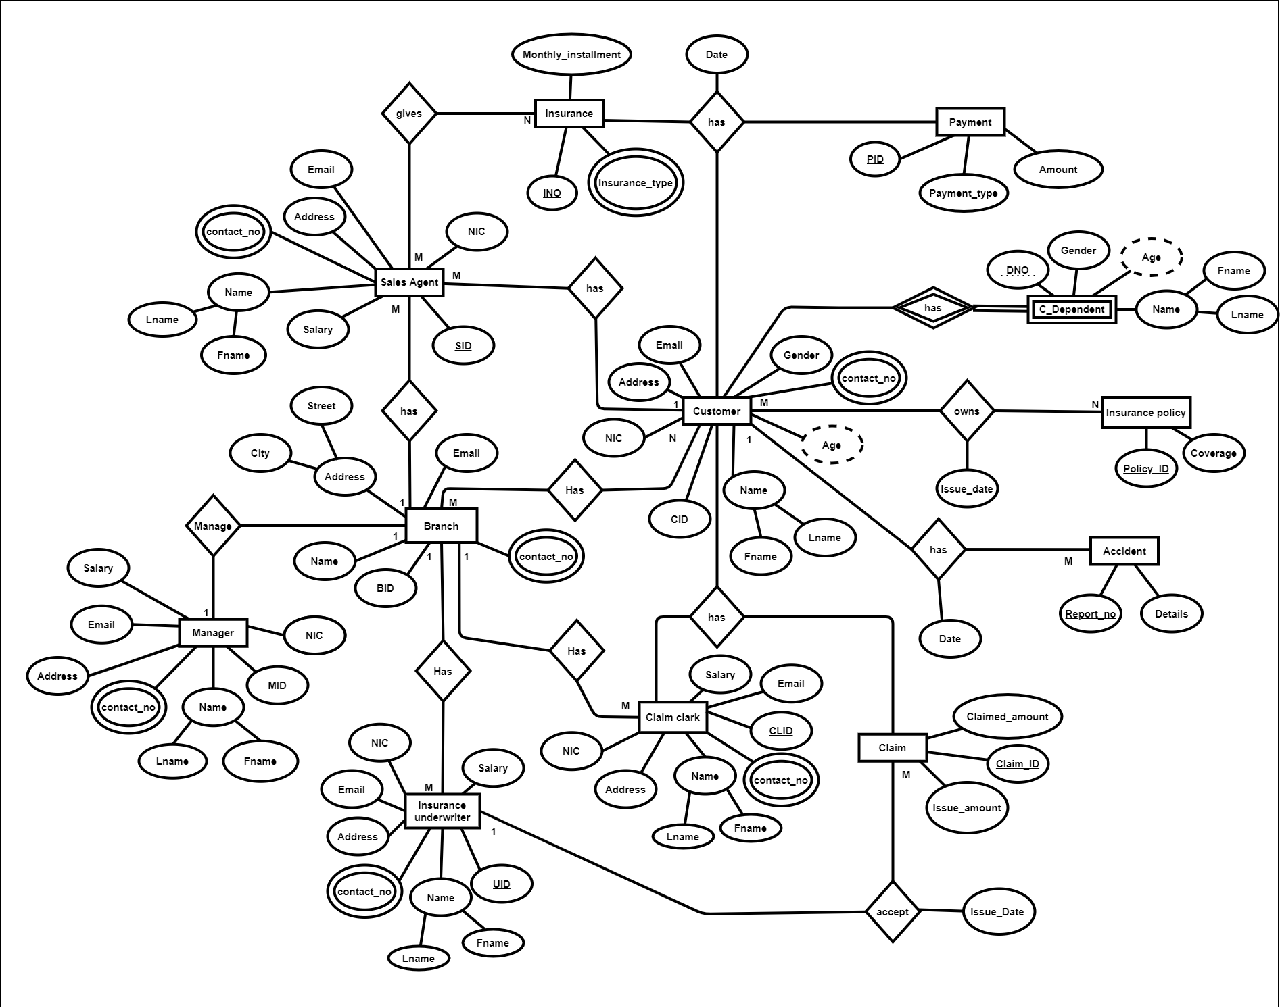

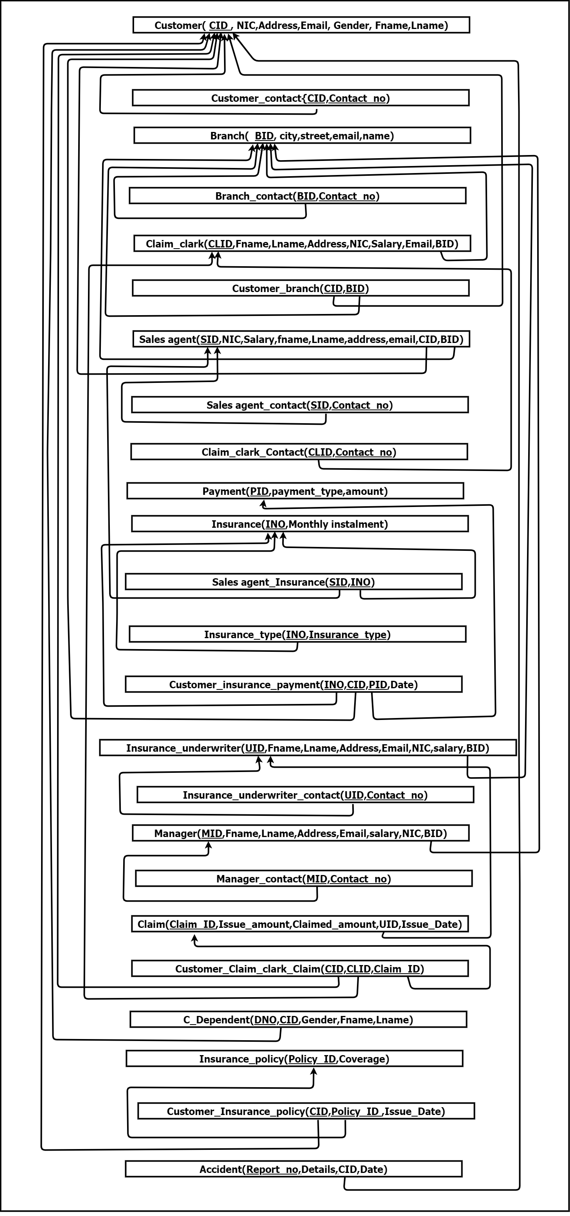**The Schema of the Database**

## SQL Commands to Create the Database Tables

CREACREATE TABLE Customer (

CID varchar(20),

NIC varchar(15),

Address varchar(100),

Email varchar(100),

Gender varchar(20),

Fname varchar(50),

Lname varchar(50),

CONSTRAINT pk_Customer PRIMARY KEY(CID)

);

INSERT INTO Customer VALUES('C001', '982783672V', '150/2,Malwana,Biyagama', 'tharukaushi98@gmail.com', 'Female', 'Tharu', 'Kaushi');

INSERT INTO Customer VALUES('C002', '982716872V', '12, Yakkala, Gampaha', 'gaiya99@gmail.com', 'Male', 'Gayashan', 'Hettiarachchi');

INSERT INTO Customer VALUES('C003', '991683672V', '74/4,Malwana,Dompe', 'kalana99@gmail.com', 'Male', 'Kalana', 'Maduranga');

INSERT INTO Customer VALUES('C004', '2000563672V', '150/2,Malabe,Kaduwela', 'randi98@gmail.com', 'Female', 'Randi', 'Rashmika');

INSERT INTO Customer VALUES('C005', '9782783672V', '150/2,Malwana,Baththaramulla', 'shashini98@gmail.com', 'Female', 'shashini', 'Kushani');

CREATE TABLE Customer_contact (

CID varchar(20),

Contact_no int,

CONSTRAINT pk_Customer_contact PRIMARY KEY(CID,Contact_no),

CONSTRAINT fk_Customer_contact FOREIGN KEY(CID) REFERENCES Customer(CID)

);

INSERT INTO Customer_contact VALUES('C001','0777459641')

INSERT INTO Customer_contact VALUES('C002','0777456641');

INSERT INTO Customer_contact VALUES('C003','0777259641');

INSERT INTO Customer_contact VALUES('C004','0777457641');

INSERT INTO Customer_contact VALUES('C005','0778459641');

CREATE TABLE Branch (

BID varchar(20),

City varchar(50),

Street varchar(50),

Email varchar(100),

Name varchar(50),

CONSTRAINT pk_Branch PRIMARY KEY(BID)

);

INSERT INTO Branch VALUES('B001','Malawana','Valgama','rani123@gmail.com','Rani');

INSERT INTO Branch VALUES('B002','Biyagama','Colombo','kamal123@gmail.com','Kamal');

INSERT INTO Branch VALUES('B003','Yakkala','Kadavatha','piyal123@gmail.com','Piyal');

INSERT INTO Branch VALUES('B004','Dompe','Delgoda','kumara123@gmail.com','Kumara');

INSERT INTO Branch VALUES('B005','kaduwela','Malabe','nimal123@gmail.com','Nimal');

CREATE TABLE Branch_contact (

BID varchar(20),

Contact_no int,

CONSTRAINT pk_Branch_contact PRIMARY KEY(BID,Contact_no),

CONSTRAINT fk_Branch_contact FOREIGN KEY(BID) REFERENCES Branch(BID)

);

INSERT INTO Branch_contact VALUES('B001','0777459641');

INSERT INTO Branch_contact VALUES('B002','0775456641');

INSERT INTO Branch_contact VALUES('B003','0777299641');

INSERT INTO Branch_contact VALUES('B004','0777457643');

INSERT INTO Branch_contact VALUES('B005','0778459741');

CREATE TABLE Claim_clark (

CLID varchar(20),

NIC varchar(15),

Address varchar(100),

Email varchar(100),

Salary int,

Fname varchar(50),

Lname varchar(50),

BID varchar(20),

CONSTRAINT pk_Claim_clark PRIMARY KEY(CLID),

CONSTRAINT fk_Claim_clark FOREIGN KEY(BID) REFERENCES Branch(BID)

);

INSERT INTO Claim_clark VALUES('CL001', '982783672V', '150/2,Malwana,Biyagama', 'tharukaushi98@gmail.com','75000', 'Tharu', 'Kaushi','B001');

INSERT INTO Claim_clark VALUES('CL002', '982716872V', '12, Yakkala, Gampaha', 'gaiya99@gmail.com','35000', 'Gayashan', 'Hettiarachchi','B002');

INSERT INTO Claim_clark VALUES('CL003', '991683672V', '74/4,Malwana,Dompe', 'kalana99@gmail.com','65000' , 'Kalana', 'Maduranga','B003');

INSERT INTO Claim_clark VALUES('CL004', '2000563672V', '150/2,Malabe,Kaduwela', 'randi98@gmail.com','55000' , 'Randi', 'Rashmika','B004');

INSERT INTO Claim_clark VALUES('CL005', '9782783672V', '150/2,Malwana,Baththaramulla', 'shashini98@gmail.com','78000', 'shashini', 'Kushani','B005');

CREATE TABLE Customer_branch(

CID varchar(20),

BID varchar(20),

CONSTRAINT pk_Customer_branch PRIMARY KEY(CID,BID),

CONSTRAINT fk_Customer_branch1 FOREIGN KEY(CID) REFERENCES Customer(CID),

CONSTRAINT fk_Customer_branch2 FOREIGN KEY(BID) REFERENCES Branch(BID)

);

INSERT INTO Customer_branch VALUES('C001','B001');

INSERT INTO Customer_branch VALUES('C002','B002');

INSERT INTO Customer_branch VALUES('C003','B003');

INSERT INTO Customer_branch VALUES('C004','B004');

INSERT INTO Customer_branch VALUES('C005','B005');

CREATE TABLE Sales_agent(

SID varchar(20),

NIC varchar(15),

Salary int,

Fname varchar(50),

Lname varchar(50),

Address varchar(100),

Email varchar(100),

BID varchar(20),

CID varchar(20),

CONSTRAINT pk_Sales_agent PRIMARY KEY(SID),

CONSTRAINT fk_Sales_agent1 FOREIGN KEY(BID) REFERENCES Branch(BID),

CONSTRAINT fk_Sales_agent2 FOREIGN KEY(CID) REFERENCES Customer(CID)

);

INSERT INTO Sales_agent VALUES('S001', '982783672V', '25000', 'Gayashan', 'hettiarachchi', '150/2,Malwana,Biyagama', 'tharukaushi98@gmail.com','B001','C001');

INSERT INTO Sales_agent VALUES('S002', '982716872V', '30000', 'Tharusha', 'kausha', '150/2,Malwana,Biyagama', 'gaiya99@gmail.com','B002','C001');

INSERT INTO Sales_agent VALUES('S003', '991683672V', '35000', 'Kalana','abey', '150/2,Malwana,Biyagama', 'kalana99@gmail.com','B003','C001');

INSERT INTO Sales_agent VALUES('S004', '2000563672V', '45000', 'Rashmila', 'nethmi', '150/2,Malwana,Biyagama', 'randi98@gmail.com','B004','C001');

INSERT INTO Sales_agent VALUES('S005', '9782783672V', '55000', 'Shashini', 'methushi', '150/2,Malwana,Biyagama', 'shashini98@gmail.com','B005','C001');

CREATE TABLE Sales_agent_contact (

SID varchar(20),

Contact_no int,

CONSTRAINT pk_Sales_agent_contact PRIMARY KEY(SID,Contact_no),

CONSTRAINT fk_Sales_agent_contact FOREIGN KEY(SID) REFERENCES Sales_agent(SID)

);

INSERT INTO Sales_agent_contact VALUES('S001','0777459641');

INSERT INTO Sales_agent_contact VALUES('S002','0775456641');

INSERT INTO Sales_agent_contact VALUES('S003','0777299641');

INSERT INTO Sales_agent_contact VALUES('S004','0777457643');

INSERT INTO Sales_agent_contact VALUES('S005','0778459741');

CREATE TABLE Claim_clark_contact (

CLID varchar(20),

Contact_no int,

CONSTRAINT pk_Claim_clark_contact PRIMARY KEY(CLID,Contact_no),

CONSTRAINT fk_Claim_clark_contact FOREIGN KEY(CLID) REFERENCES Claim_clark(CLID)

);

INSERT INTO Claim_clark_contact VALUES('CL001','0777459641');

INSERT INTO Claim_clark_contact VALUES('CL002','0775456641');

INSERT INTO Claim_clark_contact VALUES('CL003','0777299641');

INSERT INTO Claim_clark_contact VALUES('CL004','0777457643');

INSERT INTO Claim_clark_contact VALUES('CL005','0778459741');

CREATE TABLE Payment(

PID varchar(20),

Payment_type varchar(20),

amount int,

CONSTRAINT pk_Payment PRIMARY KEY(PID),

);

INSERT INTO Payment VALUES('P001','Cash', '25000');

INSERT INTO Payment VALUES('P002','Card', '15000');

INSERT INTO Payment VALUES('P003','Card', '1000');

INSERT INTO Payment VALUES('P004','Card', '23000');

INSERT INTO Payment VALUES('P005','Cash', '14000');

CREATE TABLE Insurance(

INO varchar(20),

Monthly_Instalment varchar(20),

CONSTRAINT pk_Insurance PRIMARY KEY(INO),

);

INSERT INTO Insurance VALUES('I001','2000');

INSERT INTO Insurance VALUES('I002','2500');

INSERT INTO Insurance VALUES('I003','5000');

INSERT INTO Insurance VALUES('I004','1500');

INSERT INTO Insurance VALUES('I005','4500');

CREATE TABLE Sales_agent_Insurance(

SID varchar(20),

INO varchar(20),

CONSTRAINT pk_Sales_agent_Insurance PRIMARY KEY(SID,INO),

CONSTRAINT fk_Sales_agent_Insurance1 FOREIGN KEY(SID) REFERENCES Sales_agent(SID),

CONSTRAINT fk_Sales_agent_Insurance2 FOREIGN KEY(INO) REFERENCES Insurance(INO)

);

INSERT INTO Sales_agent_Insurance VALUES('S001','I001');

INSERT INTO Sales_agent_Insurance VALUES('S002','I002');

INSERT INTO Sales_agent_Insurance VALUES('S003','I003');

INSERT INTO Sales_agent_Insurance VALUES('S004','I004');

INSERT INTO Sales_agent_Insurance VALUES('S005','I005');

CREATE TABLE Insurance_type(

INO varchar(20),

Insurance_type varchar(50),

CONSTRAINT pk_Insurance_type PRIMARY KEY(INO,Insurance_type),

CONSTRAINT fk_Insurance_type FOREIGN KEY(INO) REFERENCES Insurance(INO)

);

INSERT INTO Insurance_type VALUES('I001','Life care');

INSERT INTO Insurance_type VALUES('I002','Term');

INSERT INTO Insurance_type VALUES('I003','Health');

INSERT INTO Insurance_type VALUES('I004','Term');

INSERT INTO Insurance_type VALUES('I005','Health');

CREATE TABLE Customer_Insurance_Payment(

INO varchar(20),

CID varchar(20),

PID varchar(20),

Date date,

CONSTRAINT pk_Customer_Insurance_Payment PRIMARY KEY(INO,CID,PID),

CONSTRAINT fk_Customer_Insurance_Payment1 FOREIGN KEY(INO) REFERENCES Insurance(INO),

CONSTRAINT fk_Customer_Insurance_Payment2 FOREIGN KEY(CID) REFERENCES Customer(CID),

CONSTRAINT fk_Customer_Insurance_Payment3 FOREIGN KEY(PID) REFERENCES Payment(PID),

);

INSERT INTO Customer_Insurance_Payment VALUES ('I001', 'C001' , 'P001' , '05-12-2021');

INSERT INTO Customer_Insurance_Payment VALUES ('I002', 'C002' , 'P002' , '03-05-2021');

INSERT INTO Customer_Insurance_Payment VALUES ('I003', 'C003' , 'P003' ,'04-05-2021');

INSERT INTO Customer_Insurance_Payment VALUES ('I004', 'C004' , 'P004' ,'05-05-2021');

INSERT INTO Customer_Insurance_Payment VALUES ('I005', 'C005' , 'P005' ,'06-05-2021');

CREATE TABLE Insurance_Underwriter(

UID varchar(20),

Fname varchar(50),

Lname varchar(50),

Address varchar(100),

Email varchar(100),

NIC varchar(15),

Salary int,

BID varchar(20),

CONSTRAINT pk_Insurance_Underwriter PRIMARY KEY(UID),

CONSTRAINT fk_Insurance_Underwriter FOREIGN KEY(BID) REFERENCES Branch(BID)

);

INSERT INTO Insurance_Underwriter VALUES ('U001' , 'gayashan' , 'Hetti' , '214/a ,warapalana,udathuththiripitiya','gayashan@gmail.com' , '982942762V' , '25000' , 'B001 ');

INSERT INTO Insurance_Underwriter VALUES ('U002' , 'gaya' , 'arachchi' , '214/a ,yakkala,gampaha','gaya@gmail.com' , '952942762V' , '35000' , 'B002 ');

INSERT INTO Insurance_Underwriter VALUES ('U003' , 'shan' , 'sukumal' , '214/a ,wathurugama,udathuththiripitiya','shan@gmail.com' , '992942762V' , '15000' , 'B003 ');

INSERT INTO Insurance_Underwriter VALUES ('U004' , 'yashan' , 'nimal' , '214/a ,warapalana','yashan@gmail.com' , '982942762V' , '65000' , 'B004 ');

INSERT INTO Insurance_Underwriter VALUES ('U005' , 'ashan' , 'nimsara' , '214/a ,krindiwala,udathuththiripitiya','ashan@gmail.com' , '942942762V' , '45000' , 'B005 ');

CREATE TABLE insurance_underwriter_contact(

UID varchar (20),

Contact_no int,

CONSTRAINT pk_insurance_underwriter_contact PRIMARY KEY(UID,Contact_no),

CONSTRAINT fk_insurance_underwriter_contact1 FOREIGN KEY (UID) REFERENCES Insurance_underwriter(UID));

INSERT INTO insurance_underwriter_contact VALUES('U001','0775426486');

INSERT INTO insurance_underwriter_contact VALUES('U002','0774426486');

INSERT INTO insurance_underwriter_contact VALUES('U003','0773426486');

INSERT INTO insurance_underwriter_contact VALUES('U004','0772426486');

INSERT INTO insurance_underwriter_contact VALUES('U005','0771426486');

CREATE TABLE Manager (

MID varchar(20),

Fname varchar(50),

Lname varchar(50),

Address varchar(100),

Email varchar(80),

salary INT,

NIC varchar(15),

BID varchar(20),

CONSTRAINT pk_Manager PRIMARY KEY (MID),

CONSTRAINT fk_manager FOREIGN KEY (BID) REFERENCES Branch(BID));

INSERT INTO Manager VALUES ('M001','gayashan','hettiarachchi','25/a,yakkala,gampaha','gayashan@gmail.com','25000','892942762V','B001');

INSERT INTO Manager VALUES ('M002','gaya','hettiarachchi','320/a,yakkala,gampaha','gaya@gmail.com','35000','792942762V','B002');

INSERT INTO Manager VALUES ('M003','shan','hettiarachchi','251/a,yakkala,gampaha','ashan@gmail.com','26000','692942762V','B003');

INSERT INTO Manager VALUES ('M004','ashan','hettiarachchi','23/a,yakkala,gampaha','ashan@gmail.com','28000','592942762V','B004');

INSERT INTO Manager VALUES ('M005','yashan','hettiarachchi','28/a,yakkala,gampaha','yashan@gmail.com','35400','492942762V','B005');

CREATE TABLE Contact_Manager (

MID VARCHAR (20),

Contact_no VARCHAR(20),

CONSTRAINT pk_Contact_Manager PRIMARY KEY(MID,Contact_no),

CONSTRAINT fk_Contact_Manager FOREIGN KEY(MID) REFERENCES Manager(MID));

INSERT INTO Contact_Manager VALUES ('M001','0770426486');

INSERT INTO Contact_Manager VALUES ('M002','0780426486');

INSERT INTO Contact_Manager VALUES ('M003','0750426486');

INSERT INTO Contact_Manager VALUES ('M004','0710426486');

INSERT INTO Contact_Manager VALUES ('M005','0745426486');

CREATE TABLE Claim(

Claim_ID varchar(20),

Issue_amount int,

Claimed_amount int,

Issue_Date date,

UID varchar(20),

CONSTRAINT pk_Claim PRIMARY KEY(Claim_ID),

CONSTRAINT fk_Claim FOREIGN KEY(UID) REFERENCES Insurance_Underwriter(UID)

);

INSERT INTO Claim VALUES ('CLI001','75000','50000','03-05-2021','U001');

INSERT INTO Claim VALUES ('CLI002','20000','36000','04-05-2021','U002');

INSERT INTO Claim VALUES ('CLI003','45000','89000','05-05-2021','U003');

INSERT INTO Claim VALUES ('CLI004','52000','65000','06-05-2021','U004');

INSERT INTO Claim VALUES ('CLI005','55000','66000','07-05-2021','U005');

CREATE TABLE Customer_Claim_clark_Claim(

CID varchar(20),

CLID varchar(20),

Claim_ID varchar(20),

CONSTRAINT pk_Customer_Claim_clark_Claim PRIMARY KEY(CID,CLID,Claim_ID),

CONSTRAINT fk_Customer_Claim_clark_Claim1 FOREIGN KEY(CID) REFERENCES Customer(CID),

CONSTRAINT fk_Customer_Claim_clark_Claim2 FOREIGN KEY(CLID) REFERENCES Claim_clark(CLID),

CONSTRAINT fk_Customer_Claim_clark_Claim3 FOREIGN KEY(Claim_ID) REFERENCES Claim(Claim_ID),

);

INSERT INTO Customer_Claim_clark_Claim VALUES('C001','CL001','CLI001');

INSERT INTO Customer_Claim_clark_Claim VALUES('C002','CL002','CLI002');

INSERT INTO Customer_Claim_clark_Claim VALUES('C003','CL003','CLI003');

INSERT INTO Customer_Claim_clark_Claim VALUES('C004','CL004','CLI004');

INSERT INTO Customer_Claim_clark_Claim VALUES('C005','CL005','CLI005');

CREATE TABLE C_Dependent(

CID varchar(20),

DNO varchar(20),

Gender varchar(20),

Fname varchar(50),

Lname varchar(50),

CONSTRAINT pk_C_Dependent PRIMARY KEY(CID,DNO),

CONSTRAINT fk_C_Dependent FOREIGN KEY(CID) REFERENCES Customer(CID),

);

INSERT INTO C_Dependent VALUES('C001','D001','MALE','GAYASHAN','DULA');

INSERT INTO C_Dependent VALUES('C002','D002','FEMALE','SHANI','DULINI');

INSERT INTO C_Dependent VALUES('C003','D003','MALE','YASHAN','DULANJANA');

INSERT INTO C_Dependent VALUES('C004','D004','FEMALE','THARUSHA','DULMI');

INSERT INTO C_Dependent VALUES('C004','D005','MALE','KALANA','DULAMITH');

CREATE TABLE Insurance_policy(

Policy_ID varchar(20),

Coverage varchar(20),

CONSTRAINT pk_Insurance_policy PRIMARY KEY(Policy_ID)

);

INSERT INTO Insurance_policy VALUES('PL001','3 YEARS');

INSERT INTO Insurance_policy VALUES('PL002','4 YEARS');

INSERT INTO Insurance_policy VALUES('PL003','5 YEARS');

INSERT INTO Insurance_policy VALUES('PL004','6 YEARS');

INSERT INTO Insurance_policy VALUES('PL005','8 YEARS');

CREATE TABLE Customer_Insurance_policy(

CID varchar(20),

Policy_ID varchar(20),

Issue_Date date,

CONSTRAINT pk_Customer_Insurance_policy PRIMARY KEY(CID,Policy_ID),

CONSTRAINT fk_Customer_Insurance_policy1 FOREIGN KEY(CID) REFERENCES Customer(CID),

CONSTRAINT fk_Customer_Insurance_policy2 FOREIGN KEY(Policy_ID) REFERENCES Insurance_policy(Policy_ID)

);

INSERT INTO Customer_Insurance_policy VALUES ('C001','PL001','12/05/2021');

INSERT INTO Customer_Insurance_policy VALUES ('C002','PL002','12/15/2021');

INSERT INTO Customer_Insurance_policy VALUES ('C003','PL003','12/25/2021');

INSERT INTO Customer_Insurance_policy VALUES ('C004','PL004','12/15/2021');

INSERT INTO Customer_Insurance_policy VALUES ('C005','PL005','12/02/2021');

CREATE TABLE Accident(

Report_no varchar(20),

Details varchar(200),

Date date,

CID varchar(20),

CONSTRAINT pk_Accident PRIMARY KEY(Report_no),

CONSTRAINT fk_Accident FOREIGN KEY(CID) REFERENCES Customer(CID),

);

INSERT INTO Accident VALUES ('RN001','N/A','12/05/2021','C001');

INSERT INTO Accident VALUES ('RN002','N/A','12/15/2021','C002');

INSERT INTO Accident VALUES ('RN003','N/A','12/25/2021','C003');

INSERT INTO Accident VALUES ('RN004','N/A','12/15/2021','C004');

INSERT INTO Accident VALUES ('RN005','N/A','12/08/2021','C005');

### Sampale of Table

Individual Contribution :

Student ID - IT19985428

Name - Rathnasiri.K.D.M.M

Cover Area :

* Writing SQL Commands
* SQL Sampale

Special Contribution :

* Refresh idea about the project
* Checking the errors in report
* Creating assignment report
* Discuss and support for members how to do the project

learnt through the project :

* How to write The Hypothetical Scenario
* How to identify the requirements
* How to draw the ER diagram and relationship
* How to draw The Schema of the Database
* How to create SQl commends and Input data
* How to identify the Project security requirements and special requirements.

Student ID - IT19049946

Name - Thilakarathne H.P.A.S

**Covered area :**Wrote the hypothetical scenario for the use case. Wrote the introduction for the requirement analysis document and Created the requirement analysis document to identify entities and attributes.

**Special contribution :**Reviewed the ER diagram. Reviewed the sql commands written. Reviewed the special performance considerations and security considerations. Reviewed the relational schema.

**Learnt through the project:**Mainly I learnt through the project on how to create a

requirement analysis document and identifying entities and attributes for

a real world use case. I was able to ER diagrams and write the sql commands. And i got to know how to draw the relational schema. And this project helped me to identify special performance and security concerns of databases.

Student ID - IT19984674

Name - Wanninayake K.M.I.S

* **Covered Area :**Wrote the hypothetical scenario for the use case. Wrote the introduction for the requirement analysis document and Created the requirement analysis document to identify entities and attributes.

* **Special contribution:**

Reviewed the ER diagram. Reviewed the sql commands written. I learned how to create tables correctly and add data to it.

* **Learnt through the project**
* Requirements Analysis.
* Conceptual Database Design.
* Logical Database Design (Map ER to Relational Schema).
* Physical Database Design.
* Security Design.

Student ID - IT19987576

Name - Shehan R.H.A

* **Covered Area :**

* Draw ER the diagram in Drow.io
* Draw the schema in Drow.io

* **Special contribution:**

I learned while doing the project how to identify the entity attribute and relationship to design an ER Diagram and schema. I learned how to create tables correctly and add data to it. And this project helped me to identify special performance and security concerns of databases

* **Learnt through the project:**

* Requirements Analysis.
* Conceptual Database Design.
* Logical Database Design (Map ER to Relational Schema).
* Physical Database Design.
* Security Design.

Student ID - IT19986418

Name - Bogahawatta L.B.G.D.P.K

